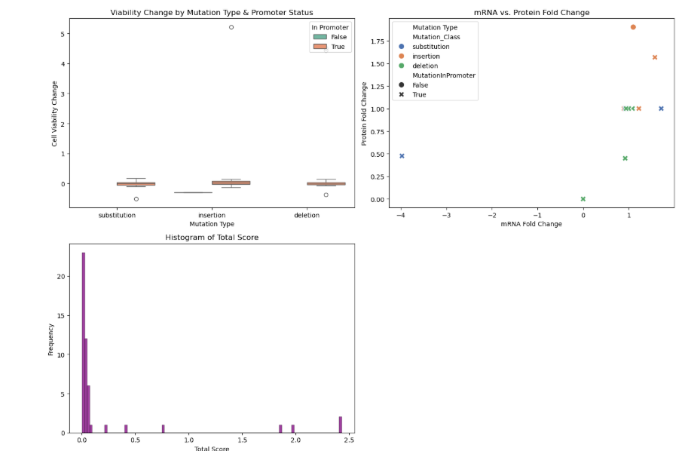

This multi-panel graph visually integrates boxplot, scatter plot, and histogram data to highlight how mutation types-especially those in promoter regions affect cell viability and gene expression, thereby guiding the prioritization of candidates genes.